LABORATORIYA ISHI - 7
Mavzu: PHP’da sessiya va cookie’lar bilan ishlash
Ishning maqsadi
Talabalarda PHP dasturlash tilida:
- Cookie va Session tushunchalarini o‘rganish
- Ularni yaratish, o‘qish va o‘chirishni amalda bajarish
- Foydalanuvchi ma’lumotlarini vaqtinchalik saqlashni tushunish

Nazariy qism
Cookie nima?
Cookie — bu foydalanuvchi brauzerida saqlanadigan kichik hajmdagi ma’lumot.
Xususiyatlari:
- Brauzerda saqlanadi
- Belgilangan vaqtgacha yashaydi
- Serverga har so‘rovda yuboriladi
PHP’da cookie yaratish:
setcookie("username", "Ali", time() + 3600);
Cookie’ni o‘qish:
echo $_COOKIE['username'];
Cookie’ni o‘chirish:
setcookie("username", "", time() - 3600);

Session nima?
Session — bu serverda saqlanadigan foydalanuvchi ma’lumotidir.
Xususiyatlari:
- Serverda saqlanadi
- Xavfsizroq
- Brauzer yopilganda yoki sessiya tugaganda o‘chadi
Session boshlash:
session_start();

Session qiymat berish:
$_SESSION['username'] = "Ali";
Session o‘qish:
echo $_SESSION['username'];
Session o‘chirish:
session_destroy();
Topshiriqlar

7-topshiriq
Vazifa: Saytni rangsiz (grayscale) rejimga o‘tkazish va dark mode funksiyalarini birgalikda ishlaydigan qilib yarating. Sozlamalar saqlansin.
(Ikkalasi → cookie)
Fayllar tartibi:
grayscale-darkmode/
│
├── index.php
├── style.css
└── script.js

KOD

style.css

/* style.css */

body {
font-family: Arial, sans-serif;
transition: 0.3s;
background-color: white;
color: black;
}

/* Dark mode */
body.dark {
background-color: #121212;
color: white;
}

/* Grayscale */
body.grayscale {
filter: grayscale(100%);
}

/* Tugmalar */
button {
padding: 10px 15px;
margin: 5px;
cursor: pointer;
border: none;
background-color: #007bff;
color: white;
border-radius: 4px;
}

button:hover {
background-color: #0056b3;
}

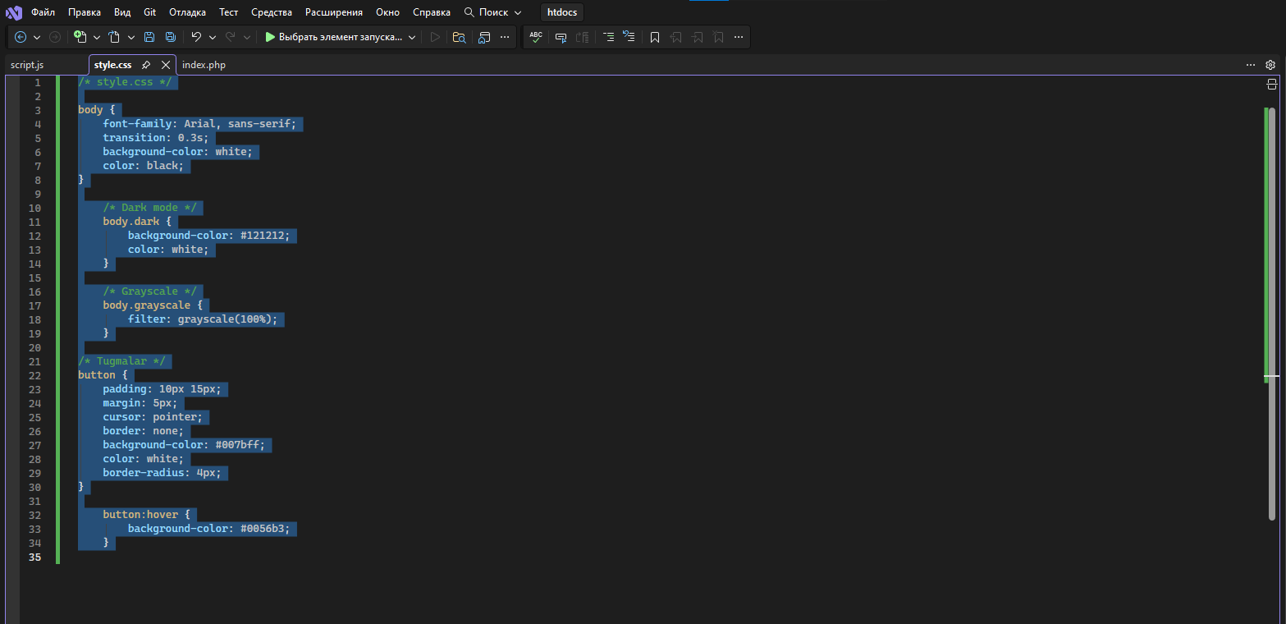

index.php

<?php
// Cookie qiymatlarini olish
$dark = isset($_COOKIE['darkmode']) && $_COOKIE['darkmode'] == 'dark' ? 'dark' : '';
$gray = isset($_COOKIE['grayscale']) && $_COOKIE['grayscale'] == 'grayscale' ? 'grayscale' : '';
?>

<!DOCTYPE html>
<html>
<head>
<meta charset="UTF-8">
<title>Dark + Grayscale</title>
<link rel="stylesheet" href="style.css">
</head>
<body class="<?php echo $dark . ' ' . $gray; ?>">

<h1>Sayt Rejimlari</h1>

<button onclick="toggleDark()">Dark Mode</button>
<button onclick="toggleGray()">Grayscale</button>

<p>Bu oddiy matn. Rejimlarni sinab ko‘ring.</p>

<script src="script.js"></script>
</body>
</html>
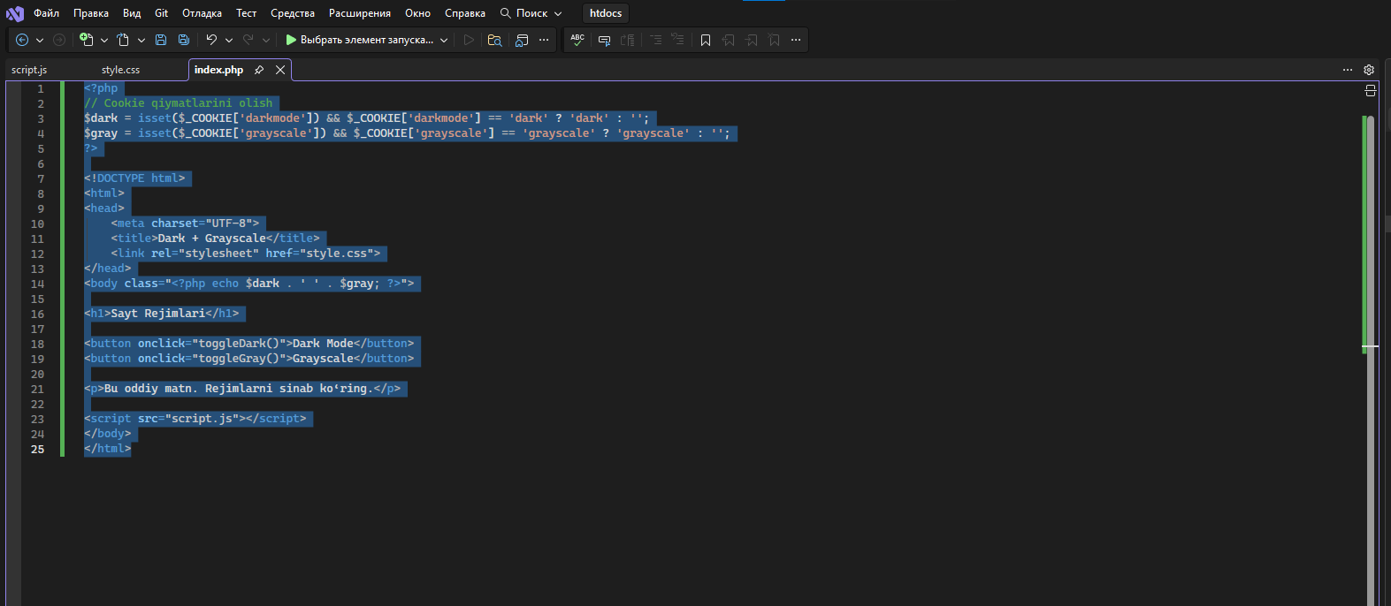

script.js

// Dark Mode toggle
function toggleDark() {
document.body.classList.toggle("dark");
let enabled = document.body.classList.contains("dark");
// Cookie 7 kun saqlash
document.cookie = "darkmode=" + (enabled ? "dark" : "") + "; max-age=" + (60*60*24*7) + "; path=/";
}

// Grayscale toggle
function toggleGray() {
document.body.classList.toggle("grayscale");
let enabled = document.body.classList.contains("grayscale");
// Cookie 7 kun saqlash
document.cookie = "grayscale=" + (enabled ? "grayscale" : "") + "; max-age=" + (60*60*24*7) + "; path=/";
}

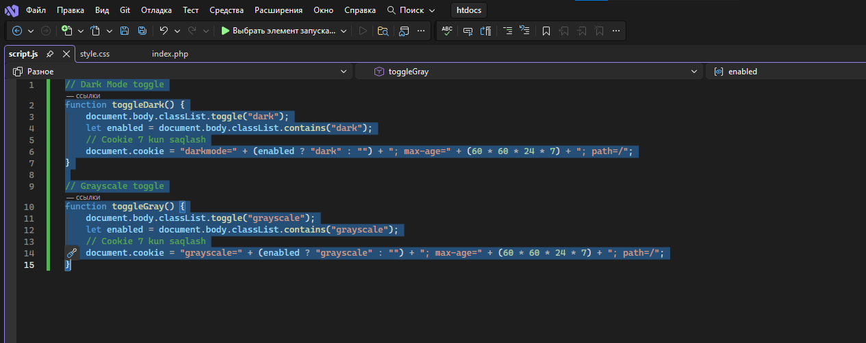

Natija

